**Raspberry Pi OS**

Link:

<https://www.raspberrypi.com/software/>

Steps are listed below.

# Step 1: Installing the OS

Installed the OS on the SD Card

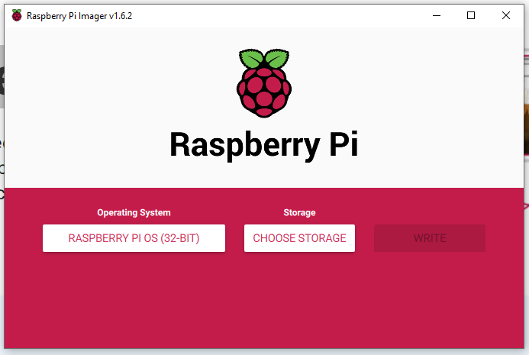

# Step 2: Connecting via SSH

Download SSH and put it on the boot drive on the SD Card.

From here: <https://storage.googleapis.com/marketing-files/YouTube/RaspberryPi-Zero-Setup/ssh>

SSH is needed in order to connect to the Raspberry Pi throw SSH on the same network remotely.

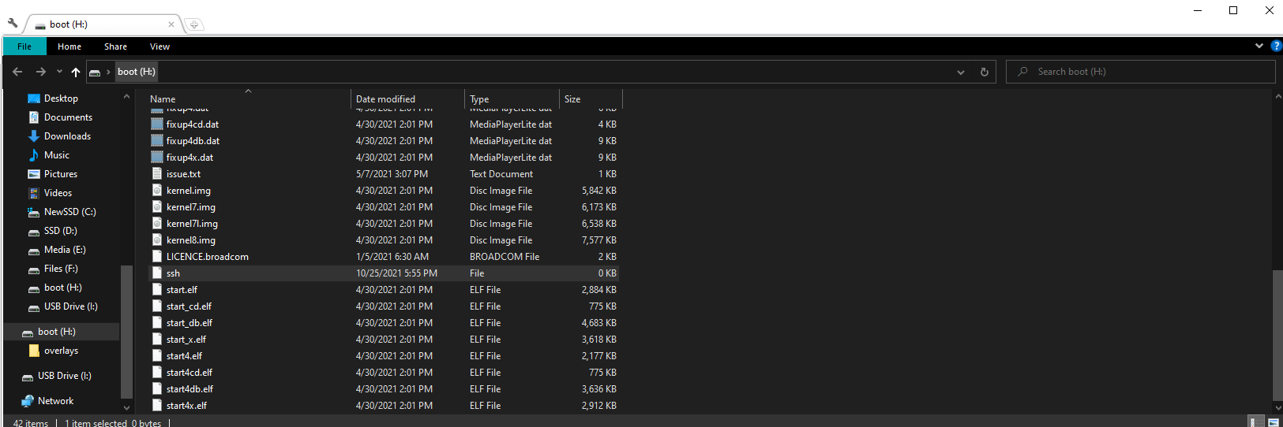

Then to connect to the Raspberry Pi we need PuTTY.

Download PuTTY

Link: <https://www.chiark.greenend.org.uk/~sgtatham/putty/latest.html>

Enter raspberrypi or raspberrypi.local as the address with port 22.

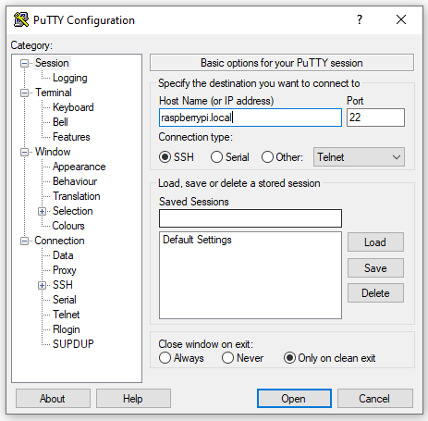

Enter pi as your username and raspberry as your password.

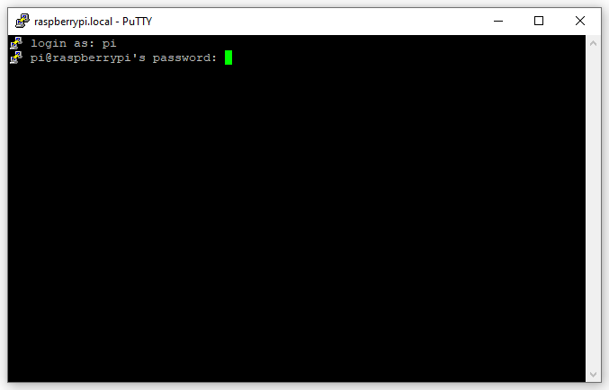

# Step 3: Enabling connection over VNC

Enter sudo raspi-config at the command prompt.



To enable VNC go to **Interfacing Options ->VNC ->Enter**

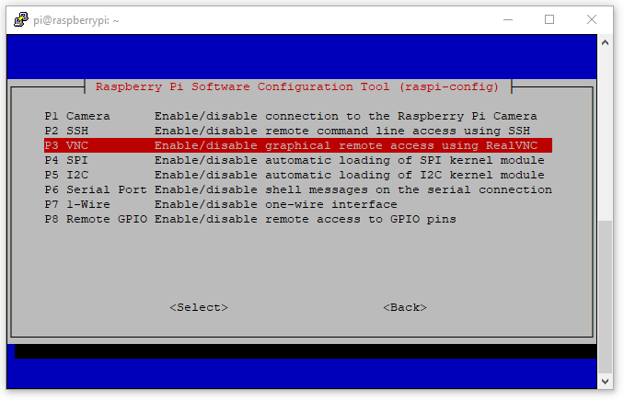

When you enable it, you will get this message.



# Step 4: Download VNC

Link:

<https://www.realvnc.com/en/connect/download/viewer/>

# Step 5: Connect throw VNC

Start a new connection.

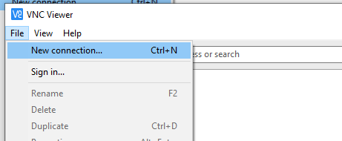

Enter the address for the Raspberry Pi as raspberrypi.local and then name the connection.

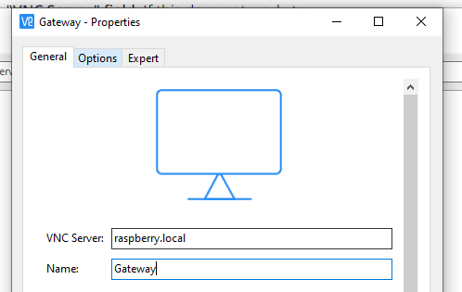

Start the connection.

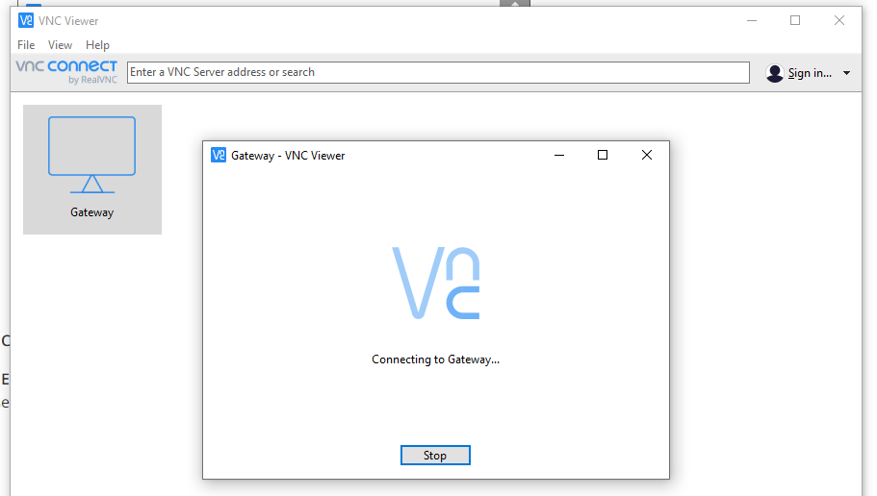

Log into the Raspberry Pi.

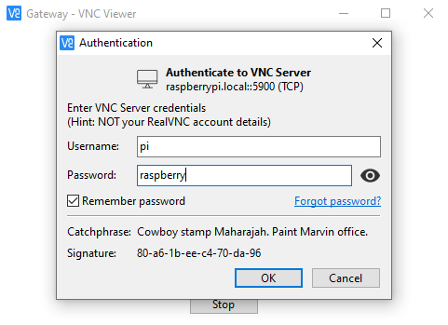

# Step 6: Change the Password

To avoid security risk, we changed the password.

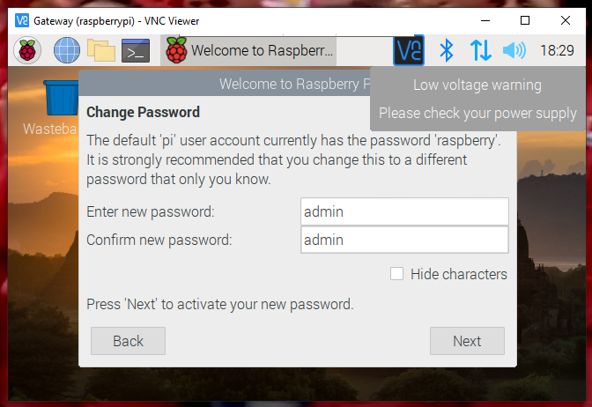

Reconnect via the new password.

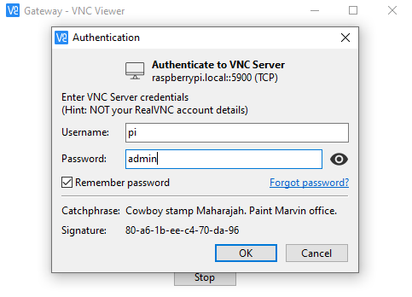

# Step 7: Screen Resolution

